“The Evolution and Mechanisms of Generative AI: A Deep Dive into DALL·E”

A Seminar report for the evaluation and partial fulfillment of the requirement for the award of the degree
B. Tech CSE (specialization in Machine Learning)
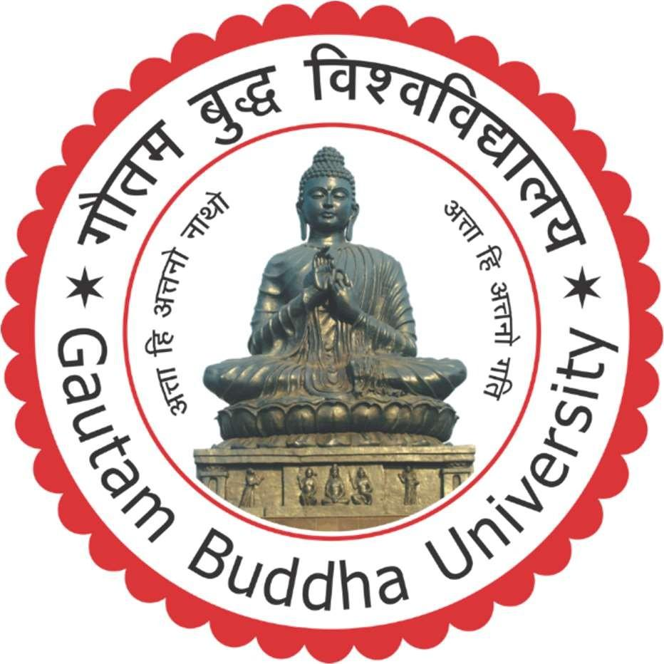

Submitted by:
Parnika Singh (215/UCM/017)

UNDER THE SUPERVISION OF

Ms. Manjari Gangwar

UNIVERSITY SCHOOL OF INFORMATION AND COMMUNICATION
TECHNOLOGY, GAUTAM BUDDHA UNIVERSITY
GREATER NOIDA –201312, GAUTAM BUDDHA NAGAR
UTTAR PRADESH, INDIA
MARCH 2025



SCHOOL OF INFORMATION AND COMMUNICATION TECHNOLOGY GAUTAM BUDDHA UNIVERSITY, GREATER NOIDA, 201312, U. P., (INDIA)

Candidate’s Declaration
I, hereby, certify that the work embodied in this report entitled “The Evolution and Mechanisms of Generative AI: A Deep Dive into DALL·E” in partial fulfillment of the requirements for the award of the Degree of B. Tech. CSE with specialization in Machine Learning submitted to the School of Information and Communication Technology, Gautam Buddha University, Greater Noida is an authentic record of my own work carried out under the supervision of Ms. Manjari Gangwar, department of Computer Science and Engineering, University School of Information and Communication Technology. The matter presented in this report has not been submitted in any other University / Institute for the award of any other degree or diploma. Responsibility for any plagiarism related issue stands solely with me.

NAME ROLL NO SIGNATURE

Parnika Singh 215/UCM/017

This is to certify that the above statement made by the candidate is correct to the best of my knowledge and belief. However, responsibility for any plagiarism related issue solely stands with the student.

Signature of the Supervisor:
Name: Ms. Manjari Gangwar
Date: 5th March, 2025
Place: Gautam Budh Nagar

Acknowledgement
I would like to express my sincere gratitude to all those who helped me throughout the course of this internship. It would not have been possible without the support and assistance of many individuals and organizations, and I am deeply thankful for their contributions.
First and foremost, I am highly indebted to Ms. Manjari Gangwar, my supervisor, department of Computer Science and Engineering, University School of Information and Communication Technology. Her invaluable guidance, constant supervision, and encouragement throughout the internship were essential to my learning experience. Her support in providing crucial information regarding the training was instrumental in my success.
I would also like to thank Dr. Arun Solanki, the Head of the Department of Computer Science and Engineering, for his support, which greatly helped me in completing this training.
Lastly, I would like to express my gratitude towards my friends and family members for their constant cooperation, understanding, and encouragement, which played a key role in the successful completion of this internship.

Abstract
This report delves into the field of Generative Artificial Intelligence (AI), specifically focusing on DALL·E, a cutting-edge AI model developed by OpenAI that generates images from textual descriptions. As AI technology continues to evolve, generative models are reshaping the way digital content is created, leading to advancements in various industries such as art, marketing, entertainment, and design. The report provides an in-depth analysis of the fundamental concepts behind generative AI, its distinction from discriminative models, and various examples of generative models currently in use.
A significant portion of the report is dedicated to DALL·E, covering its working principles in a step-by-step manner. The process involves textual input processing, latent space mapping, initial image generation, refinement through diffusion models, and final rendering. These steps enable DALL·E to produce high-quality, realistic, and contextually accurate images that align with the input text. Furthermore, the report explores the evolution of DALL·E models, from DALL·E 1 to the latest DALL·E 3, highlighting improvements in resolution, coherence, text-image alignment, and user control.
The report concludes with insights into the future trajectory of generative AI, predicting further advancements in model efficiency, real-time AI-driven creativity, and expansion into various domains such as healthcare, gaming, and personalized content creation.
For further research, this report suggests exploring the enhancement of multimodal AI systems, the integration of generative AI with augmented and virtual reality, and advancements in AI interpretability and explainability. Additionally, developing AI models that can better understand cultural and contextual nuances will be essential for making generative AI more inclusive and globally applicable. The evolution of DALL·E and similar models indicates an ongoing revolution in AI-driven creativity, paving the way for new possibilities in human-AI collaboration and digital innovation.

Contents

Title I
Candidate’s Declaration II
Acknowledgement III
Abstract IV
Introduction 6
- DALL E 6
- Generative AI…………………………...…………………………………………………7
Gen AI Models 9
About DALL E 10
- Working of DALL E 10
Evolution of DALL E Models 12
- DALL E 1 12
- DALL E 2 12
- DALL E 3…………………………….…………………………………….……………12
Conclusion .13

Introduction
Generative AI (Gen AI) is a field of artificial intelligence that focuses on creating new and original content by learning patterns from existing data. Unlike traditional AI models, which are designed for classification or prediction, generative AI can produce text, images, music, and other media that mimic human creativity. It is based on deep learning techniques, primarily using neural networks that analyze vast amounts of data and generate outputs that closely resemble real-world content.
At the core of generative AI are advanced machine learning models such as transformers, generative adversarial networks (GANs), and diffusion models. These models work by identifying underlying patterns in data and using them to generate realistic outputs. Generative AI models are trained on massive datasets, learning relationships between words, pixels, or sounds, and then applying this knowledge to create new content when given input prompts.
A key feature of generative AI is its ability to generate unique and coherent outputs rather than just retrieving pre-existing data. This is achieved through probabilistic modeling, where the AI predicts the most likely sequence of elements, such as words in a sentence or pixels in an image, to create meaningful results. While the outputs are generated based on learned patterns, they often appear novel and creative, making generative AI an important advancement in artificial intelligence research.

A. DALL·E
Iis a generative AI model developed by OpenAI that specializes in creating images from textual descriptions. It is designed to understand natural language prompts and generate highly detailed and realistic images that match the given description. Unlike traditional image generation models that rely on predefined templates or modifications of existing images, DALL·E creates entirely new images by learning patterns and structures from vast datasets. This allows it to generate unique, high-quality visuals that align with human imagination and creativity.
DALL·E is based on deep learning techniques, particularly transformer architectures and diffusion models, which enable it to interpret text and translate it into coherent visual representations. The model is trained on large-scale image-text datasets, allowing it to associate words with corresponding visual features. When given a prompt, DALL·E processes the text, breaks it down into meaningful elements, and synthesizes an image that accurately represents the description.
One of the key characteristics of DALL·E is its ability to generate images that exhibit a wide range of styles, perspectives, and imaginative compositions. It can create realistic depictions, surreal artworks, and abstract visuals by understanding contextual relationships between objects, colors, and textures. This makes DALL·E an advanced and versatile AI system capable of producing detailed and contextually relevant images based on human input.

B. Generative AI

Generative AI models are designed to create new data samples similar to existing ones. Unlike traditional AI models that focus on classification or regression, generative models produce original content.

a) Discriminative VS Generative model
Discriminative and generative models represent two fundamental approaches in machine learning. Discriminative models focus on distinguishing between different classes of data by learning decision boundaries. They are primarily used for classification tasks, where the goal is to determine the probability of a given input belonging to a specific category. For instance, a spam classifier that determines whether an email is spam or not is a classic example of a discriminative model. These models work by estimating the conditional probability P(Y|X), where Y is the label, and X is the input data.
On the other hand, generative models aim to learn the underlying probability distribution of data and generate new samples that resemble the original dataset. Instead of just distinguishing between classes, generative models try to understand how data is structured by modeling the joint probability distribution P(X, Y). This enables them to create new, realistic data points based on learned patterns. For example, a generative model trained on human faces can generate completely new, artificial faces that do not belong to real individuals. Unlike discriminative models, which are focused on decision-making, generative models emphasize data creation.
A key difference between these two approaches is that discriminative models are generally more efficient at classification tasks, as they directly optimize decision boundaries, making them suitable for applications like speech recognition, sentiment analysis, and object detection. In contrast, generative models are better at tasks requiring the synthesis of new content, such as image generation, text completion, and music composition. They have a higher computational cost since they must learn the full distribution of the dataset rather than just decision boundaries.
Despite their differences, discriminative and generative models can complement each other. For instance, in Generative Adversarial Networks (GANs), a generator (generative model) and a discriminator (discriminative model) work together, where the discriminator helps improve the generator’s output by evaluating how realistic the generated samples are. This interplay enables the creation of highly realistic synthetic content.

Gen AI models

Several generative AI models have emerged in recent years, each excelling in different types of content creation. GPT (Generative Pre-trained Transformer) models, such as GPT-3 and GPT-4, are designed to generate human-like text based on input prompts, making them useful for chatbots, content creation, and automated writing.

- DALL·E, another powerful generative AI, specializes in image generation from textual descriptions, producing realistic and imaginative visuals.

- Stable Diffusion and MidJourney are other notable image-generation models that leverage advanced diffusion techniques to create high-quality images.

- StyleGAN, developed by NVIDIA, is widely used for generating realistic human faces and artistic images.

- In the domain of music, Jukebox, an AI model from OpenAI, generates music tracks in various styles.

- DeepMind’s AlphaCode is an AI model that generates code snippets and solutions to programming problems. These models demonstrate the vast potential of generative AI in various creative and technical domains.

About DALL-E

DALL·E is a generative AI model developed by OpenAI that specializes in creating images from textual descriptions. It is designed to understand natural language prompts and generate highly detailed and realistic images that match the given input. DALL·E is built upon deep learning techniques, particularly transformers and diffusion models, which allow it to interpret text and translate it into coherent visual representations. The model has been trained on extensive datasets of text-image pairs, enabling it to generate unique and imaginative visuals, including realistic depictions, artistic renderings, and surreal compositions. DALL·E's ability to synthesize complex visual scenes from simple textual inputs makes it a powerful tool for creative professionals, designers, and researchers exploring the capabilities of AI-driven image generation.

1. Working of DALL-E

DALL·E follows a structured process to generate high-quality images from textual input:
- User Input (Text Prompt): The process begins when the user provides a textual description of the desired image, such as “a futuristic city at sunset.” The quality of the input prompt plays a crucial role in determining the accuracy and creativity of the generated image.
- Text Encoding: The input text is first processed by a natural language processing (NLP) model, which converts it into numerical embeddings. These embeddings capture the semantic meaning of the text, allowing the AI to understand the relationships between different words and concepts.
- Tokenization: The encoded text is then broken down into smaller elements known as tokens. Each token represents a meaningful component of the input text, helping the AI model interpret complex descriptions more effectively.
- Latent Space Mapping: DALL·E maps the text tokens into a multidimensional latent space. This step helps establish relationships between the textual description and potential visual elements, ensuring that the generated image aligns well with the given prompt.
- Initial Image Generation: Using a transformer-based model similar to GPT, DALL·E generates an initial rough image representation. At this stage, the image may not be fully detailed, but it provides a foundational structure based on the learned relationships between text and visuals.
- Diffusion Model Refinement: The initial image undergoes refinement through a diffusion model, a process where noise is gradually added and then removed to improve clarity and detail. This iterative enhancement ensures that the final output has high-resolution and realistic textures.
- Style and Composition Adjustment: The AI refines the image by adjusting style, composition, lighting, colors, and object positioning to ensure consistency with the text prompt. This step enhances the coherence of the generated visual and adds artistic or photorealistic effects as needed.
- Final Image Rendering: After all refinements, the model synthesizes the final image. This ensures that the generated image accurately reflects the input description while maintaining a high level of visual quality.
- Output Delivery: The completed image is then displayed to the user. Users may have options to modify or regenerate the image by tweaking the prompt or applying additional AI-powered refinements.
This systematic approach enables DALL·E to generate highly detailed, realistic, or artistic images based solely on textual descriptions, making it a powerful tool for creative applications in design, marketing, entertainment, and more.

Evolution of DALL-E Models

1. DALL·E 1 (2021)
DALL·E 1 was the first iteration of OpenAI’s text-to-image model, introduced in early 2021. It was built on a transformer-based architecture similar to GPT-3 and trained on a vast dataset of text-image pairs. This model demonstrated the ability to generate diverse and creative images from text descriptions, showcasing the potential of generative AI in visual content creation. However, DALL·E 1 had notable limitations, including lower resolution, lack of fine details, and difficulties in rendering complex object relationships accurately. While groundbreaking, its results were sometimes incoherent, and it struggled with text placement within images.
2. DALL·E 2 (2022)
DALL·E 2, released in 2022, brought significant advancements over its predecessor. It introduced a diffusion-based approach, replacing the original autoregressive method, which resulted in better text-image alignment, improved coherence, and higher-resolution outputs. The model was capable of generating more realistic and detailed images, making it a valuable tool for digital artists, designers, and content creators. A key feature of DALL·E 2 was inpainting, allowing users to edit specific parts of an image while maintaining consistency and realism. Additionally, this version improved diversity in generated outputs, reducing biases and ensuring a broader range of interpretations based on text prompts.
3. DALL·E 3 (2023)
DALL·E 3, launched in 2023, represented another leap forward in image generation accuracy and user control. It significantly improved object placement, image clarity, and the ability to render fine details, such as text within images. The model also enhanced its ability to comprehend complex, nuanced prompts, producing visually coherent and contextually relevant outputs. Additionally, DALL·E 3 introduced better user interaction features, allowing for more refined image adjustments and customization. This version continued addressing challenges related to AI biases, hallucinations, and ethical concerns, ensuring a safer and more responsible deployment of AI-generated visuals.
Conclusion
The field of generative AI has seen rapid advancements, with DALL·E being one of the most revolutionary developments in text-to-image generation. Through the evolution from DALL·E 1 to DALL·E 3, OpenAI has significantly improved the model’s ability to generate high-resolution, realistic, and contextually accurate images. The integration of transformer-based architectures and diffusion models has played a crucial role in enhancing the precision and coherence of the generated outputs.
Despite its impressive capabilities, challenges such as ethical considerations, biases, and content moderation remain critical areas for further development. Ensuring responsible AI usage is essential to prevent misuse and uphold ethical standards in digital content creation. Looking ahead, generative AI is expected to advance further, with potential applications expanding into interactive media, personalized content generation, and even real-time AI-driven creativity. As researchers continue refining these models, the integration of generative AI into various industries will likely reshape how humans interact with and create digital art. The continuous improvement of DALL·E and similar models underscores the potential of AI-driven creativity, paving the way for a new era of innovation in artificial intelligence and design.

